
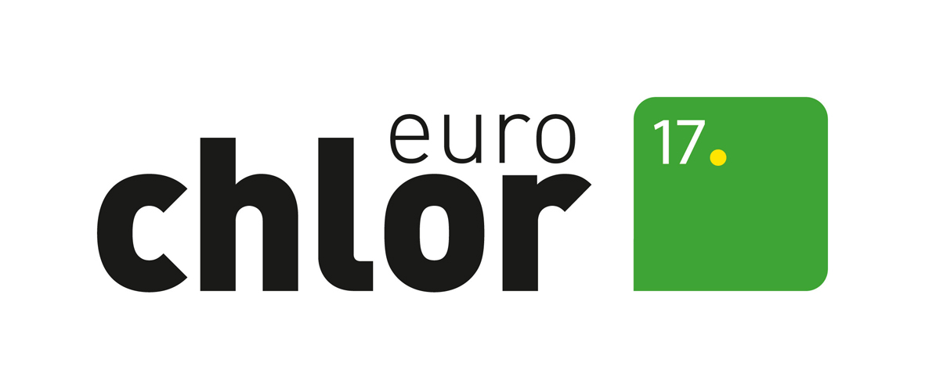

APPLICATION FORM FOR PARTNERSHIP

Company name:

Address:

Main activity (please tick)

Contact for Euro Chlor:

Name:

Job title:

Telephone:

Fax:

E-mail

Company website:

Company VAT:

Address (only if different from above)

Additional information to be given
- Areas of interest (please tick)

- Area of activity:

- By equipment supplying companies (please complete):

General activities:

Types of equipment supplied to the chlorine industry:

- By others (please complete):

Reasons for wishing to join Euro Chlor:

Please return the completed form preferably by e-mail to:
Euro Chlor
Attn: Chantal Peeters
Belliard 40, box 15
B-1040 Brussels, Belgium
Email: cpe@cefic.be

